10.4.7 Lab–Identify IPv6 Addresses

(Instructor Version)

Instructor Note: Red font color or gray highlights indicate text that appears in the instructor copy only.

# Topology

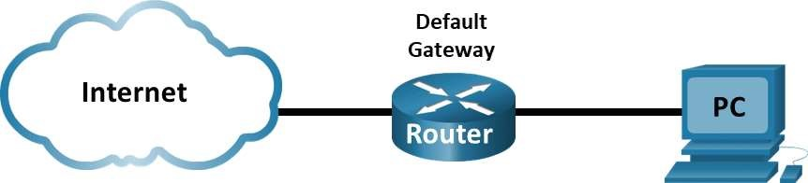

# Objectives

■ Part 1: Practice with Different Types of IPv6 Addresses.

■ Part 2: Examine a Host IPv6 Network Interface and Address.

# Background / Scenario

With the depletion of the Internet Protocol version 4 (IPv4) network address space and the adoption and transition to IPv6, networking professionals must understand how both IPv4 and IPv6 networks function. Many devices and applications already support IPv6. This includes extensive Cisco device Internetwork Operating System (IOS) support and workstation/server operating system support, such as that found in Windows and Linux.

This lab focuses on IPv6 addresses and the components of the address. In Part 1, you will identify the IPv6 address types and IPv6 addresses abbreviation. In Part 2, you will view the IPv6 settings on a PC.

Required Resources

■ 1 PC (Windows with Internet access)

# Instructions Part 1: Practice with Different Types of IPv6 Addresses

In this part, you will identify the different types of IPv6 addresses and practice compressing and decompressing IPv6 addresses.

Step 1: Match the IPv6 address to its type.

Match the IPv6 addresses to their corresponding address type. Notice that the addresses have been compressed to their abbreviated notation and that the slash network prefix number is not shown. Some answer choices must be used more than once.

Chapter 10: IPv4 and IPv6 Address Management 73

Answer choices:

1. Loopback address
2. Global unicast address
3. Link-local address
4. Unique-local address
5. Multicast address

|  |  |
| --- | --- |
| IPv6 Address | Answer |
| 2001:0db8:1:acad::fe55:6789:b210 | B |
| ::1 | A |
| fc00:22:a:2::cd4:23e4:76fa | D |
| 2033:db8:1:1:22:a33d:259a:21fe | B |
| fe80::3201:cc01:65b1 | C |
| ff00:: | E |
| ff00::db7:4322:a231:67c | E |
| ff02::2 | E |

Step 2: Practice compressing and decompressing IPv6 addresses.

Questions:

Using the rules of IPv6 address abbreviation, either compress or decompress the following addresses:

2002:0ec0:0200:0001:0000:04eb:44ce:08a2

2002:ec0:200:1::4eb:44ce:8a2

fe80:0000:0000:0001:0000:60bb:008e:7402

fe80::1:0:60bb:8e:7402

fe80::7042:b3d7:3dec:84b8

fe80:0000:0000:0000:7042:b3d7:3dec:84b8

ff00::

ff00:0000:0000:0000:0000:0000:0000:0000

2001:0030:0001:acad:0000:330e:10c2:32bf

2001:30:1:acad::330e:10c2:32bf

# Part 2: Examine a Host IPv6 Network Interface and Address

In Part 2, you will check the IPv6 network settings of your PC to identify your network interface IPv6 address.

Step 1: Check your PC IPv6 network address settings.

Verify that the IPv6 protocol is installed and active on your PC-A (check your Local Area Connection settings).

1. Navigate to the Control Panel.
2. In the Category View, click Network and Sharing Center icon. Click View network status and tasks.
3. In the Network and Sharing Center window, you will see your active networks.
4. On the left side of the window, click Change adapter settings. You should now see icons representing your installed network adapters. Right-click your active network interface (it may be an Ethernet or a Wi-Fi), and then click Properties.
5. In the Properties window, scroll through the list of items to determine whether IPv6 is present, which indicates that it is installed, and if it is also checkmarked, which indicates that it is active.
6. Select the item Internet Protocol Version 6 (TCP/IPv6) and click Properties. You should see the IPv6 settings for your network interface. Your IPv6 properties window is likely set to Obtain an IPv6 address automatically. This does not mean that IPv6 relies on the Dynamic Host Configuration Protocol (DHCP). Instead of using DHCP, IPv6 looks to the local router for IPv6 network information and then auto-configures its own IPv6 addresses. To manually configure IPv6, you must provide the IPv6 address, the subnet prefix length, and the default gateway. Click Cancel to exit the Properties windows.

Note: The local router can refer host requests for IPv6 information, especially Domain Name System (DNS) information, to a DHCPv6 server on the network.

e. After you have verified that IPv6 is installed and active on your PC, you should check your IPv6 address information.

Step 2: Verify the IPv6 address settings using the Command Prompt.

a. Open a command prompt and enter the ipconfig /all command. Your output should look similar to this:

C:\Users\user> ipconfig /all

Windows IP Configuration

<output omitted>

Wireless LAN adapter Wireless Network Connection:

Chapter 10: IPv4 and IPv6 Address Management 75

Connection-specific DNS Suffix . :

Description . . . . . . . . . . . : Intel(R) Centrino(R) Advanced-N

6200 AGN

Physical Address. . . . . . . . . : 02-37-10-41-FB-48

DHCP Enabled. . . . . . . . . . . : Yes

Autoconfiguration Enabled . . . . : Yes

Link-local IPv6 Address . . . . . : fe80::8d4f:4f4d:3237:95e2%14

(Preferred)

IPv4 Address. . . . . . . . . . . : 192.168.2.106(Preferred)

Subnet Mask . . . . . . . . . . . : 255.255.255.0

Lease Obtained. . . . . . . . . . : Sunday, January 06, 2013 9:47:36 AM

Lease Expires . . . . . . . . . . : Monday, January 07, 2013

9:47:38 AM

Default Gateway . . . . . . . . . : 192.168.2.1

DHCP Server . . . . . . . . . . . : 192.168.2.1

DHCPv6 IAID . . . . . . . . . . . : 335554320

DHCPv6 Client DUID. . . . . . . . : 00-01-00-01-14-57-84-B1-1C- C1-DE-91-C3-5D

DNS Servers . . . . . . . . . . . : 192.168.1.1

8.8.4.4

<output omitted>

b. You can see from the output that the client PC has an IPv6 link-local address with a randomly generated interface ID.

Questions:

What does it indicate about the network regarding IPv6 global unicast address, IPv6 unique-local address, or IPv6 gateway address?

It indicates that there is no IPv6 enabled gateway router providing global address, local address, or subnet information on the network.

What kind of IPv6 addresses did you find when using ipconfig /all?

Link-local address

Answers will vary, but most likely they will be link-local addresses also.

# Reflection Questions

1. How do you think you must support IPv6 in the future?

Future devices should support IPv6 because IPv6 will eventually replace IPv4. IPv6 also simplifies and speeds up data transmission. Furthermore, IPv6 was built with security in mind as it encrypts traffic and checks packet integrity.

1. Do you think IPv4 networks continue on, or will everyone eventually switch over to IPv6? How long do you think it will take?

The IPv6 adoption will continue while IPv4 network continues to support IPv4 user devices. It is still a long time before everyone switches over to IPv6 completely. This link provides some insight into the IPv6 capable by country: https://stats.labs.apnic.net/ipv6.

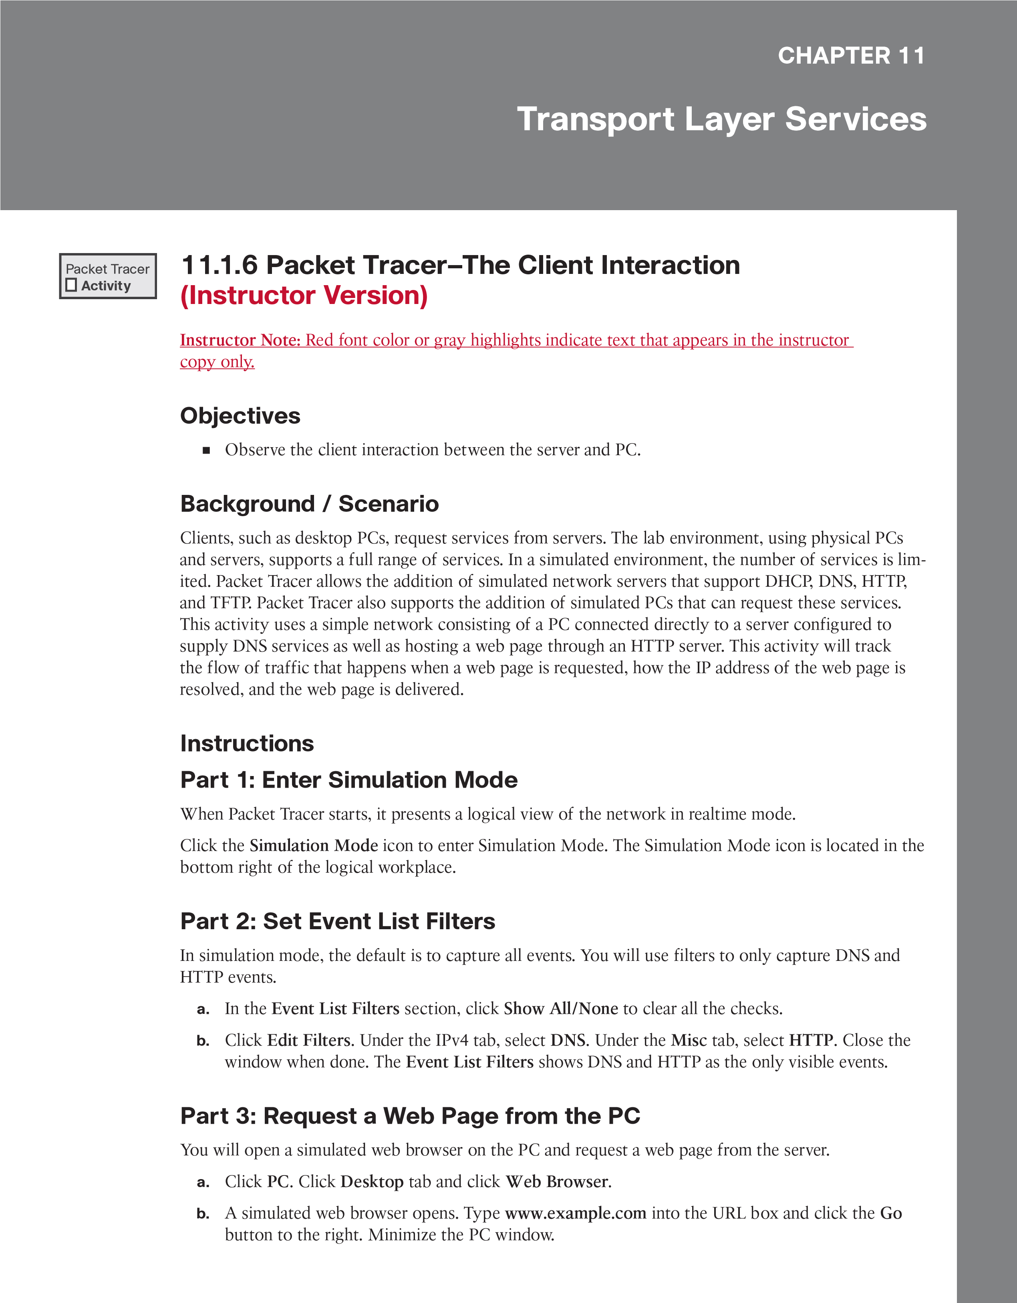

# Part 4: Run the Simulation

1. In the Play Controls section of the Simulation Panel, click Play. The exchange between the PC and the server is animated and the events are added to the Event List.

These events represent the PC’s request to resolve the URL to an IP address, the server’s providing of the IP address, the PC’s request for the web page, the server’s sending the web page in two segments, and the PC’s acknowledging the web page.

1. Click View Previous Event to continue when the buffer is full.

# Part 5: Access a Specific PDU

1. Restore the simulated PC window. Notice there is a web page displayed in the web browser. Minimize the simulated browser window.
2. In the Simulation Panel Event List section, the last column contains a colored box that provides access to detailed information about an event. Click the colored box in the first row for the first event. The PDU Information window opens.

Part 6: Examine the Contents of the PDU Information

# Window

The first tab in the PDU Information window contains information about the inbound and/or outbound PDU as it relates to the OSI model. Click Next Layer >> repeatedly to cycle through the inbound and outbound layers and read the description in the box below the layers to get an overview of how the exchange works.

Examine the PDU information for the other events to get an overview of the entire exchange process.

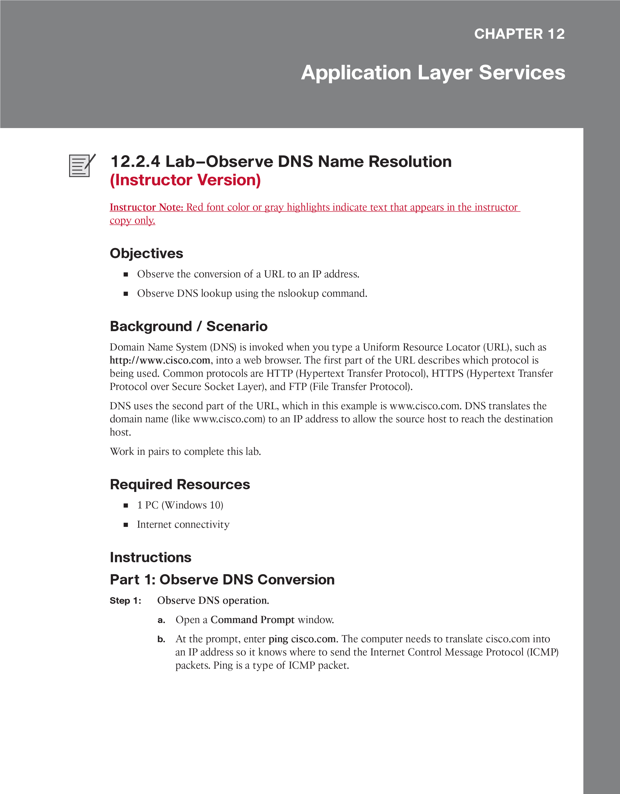

c. The first line of the output shows cisco.com converted to an IP address by DNS. You should be able to see the effect of DNS even if your school has a firewall that prevents pinging, or if Cisco has prevented people from pinging their web server.

C:\Users\Student> ping cisco.com

Pinging cisco.com [72.163.4.185] with 32 bytes of data:

Reply from 72.163.4.185: bytes=32 time=34ms TTL=244

Reply from 72.163.4.185: bytes=32 time=32ms TTL=244

Reply from 72.163.4.185: bytes=32 time=34ms TTL=244

Reply from 72.163.4.185: bytes=32 time=34ms TTL=244

Ping statistics for 72.163.4.185:

Packets: Sent = 4, Received = 4, Lost = 0 (0% loss), Approximate round trip times in milli-seconds: Minimum = 32ms, Maximum = 34ms, Average = 33ms

Questions:

Which IP address is shown on the screen?

72.163.4.185

Should cisco.com always resolve to the same IP address? Explain.

It does not always resolve to the same IP address because there are multiple public IP addresses that resolve to cisco.com.

List a few applications (besides the ping command) that need DNS to translate a domain name to an IP address. Perform an internet search as necessary.

A web browser, FTP client, or email client.

Step 2: Verify DNS operation using the nslookup command.

a. At the command prompt, enter the nslookup command.

C:\Users\Student> nslookup

Default Server: google-public-dns-a.google.com

Address: 8.8.8.8

>

The output above shows that the Default DNS Server was configured to use a Google DNS server.

Chapter 12: Application Layer Services 81

Question:

What is your Default Server listed as?

MYOPTIMUSPJS03.sunwayedu.local

1. After issuing the previous nslookup command, notice how the prompt changed to a single >. This is the prompt for the nslookup program. From this prompt, you can enter commands related to DNS.

At the prompt, type ? to see a list of all the available commands that you can use in nslookup mode.

Question:

List three commands that you can use with nslookup:

domain=NAME - set default domain name to NAME

srchlist=N1[/N2/.../N6] - set domain to N1 and search list to N1,N2, etc.

root=NAME - set root server to NAME

set type=x to set the query type, server <NAME> to set the default DNS server, and help to get command help

1. At the nslookup prompt, type cisco.com.

> cisco.com

Questions:

What is the translated IP address?

Your answers may vary. At the time of writing, these were the translated IP addresses: 2001:420:1101:1::185 and 72.163.4.185

Is the IP address an IPv4 address or an IPv6 address?

At the time of writing, the domain name was resolved for both IPv4 and IPv6.

Is it the same as the IP address shown with the ping command?

Yes.

At the prompt, type the IP address of the Cisco web server that you just found. What is the Name result?

The answer can vary. At the time of writing, www1.cisco.com was the name result.

Step 3: Identify mail servers using the nslookup command

1. To identify mail servers using nslookup, enter set type=mx.

> set type=mx

1. At the prompt, enter cisco.com.

> cisco.com

Server: google-public-dns-a.google.com

Address: 8.8.8.8

Non-authoritative answer:

cisco.com MX preference = 20, mail exchanger = rcdn-mx-01.cisco.com cisco.com MX preference = 30, mail exchanger = aer-mx-01.cisco.com cisco.com MX preference = 10, mail exchanger = alln-mx-01.cisco.com >

Question:

What are the names of the Cisco mail servers identified in the mail exchanger field?

aer-mx-01.cisco.com, alln-mx-01.cisco.com, rcdn-mx-01.cisco.com.

1. At the prompt, type exit to return to the regular command prompt.
2. At the prompt, type ipconfig /all.

Question:

Write the IP addresses of all the DNS servers that your school computer uses.

172.18.41.14

172.18.41.15

Answers will vary.

1. Enter exit to close the Command Prompt window.

# Reflection

1. If your school did not have a DNS server, what effect would this have on your use of the Internet?

We would not be able to browse the web or use any network application that relies on name to IP address translation.

1. Some companies do not dedicate a single server for DNS. Instead, the DNS server provides other functions as well. Which functions do you think might be included on a DNS server? Use the ipconfig /all command to help you with this.

Email, printer, and file-share name translations. Active Directory domain controller function.